eCMS MANUAL

Air Cargo Manifest

Department of Revenue and Customs
Ministry of Finance
Table of Contents
1. Introduction 2
2. FE user 2
3. Create Air Cargo Manifest 3
4. Track Application 5
5. Additional Air Cargo Manifest 6
6. Amend Air Cargo Manifest 6
7. Cancel Air Cargo Manifest 7
8. Air Cargo House Manifest 9
9. Create Air Cargo House Manifest 9
10. Amend and Cancel Air Cargo House Manifest 9
11. View Air Cargo Manifest Audit Details 10

Introduction

Air manifest is submitted by Declarants and CFAs. Users manually create the manifest. Users can also mark air waybills as consolidated and assign the corresponding consolidating party.

FE user

- The user needs to log into eCMS using the url: www.ecms.gov.bt

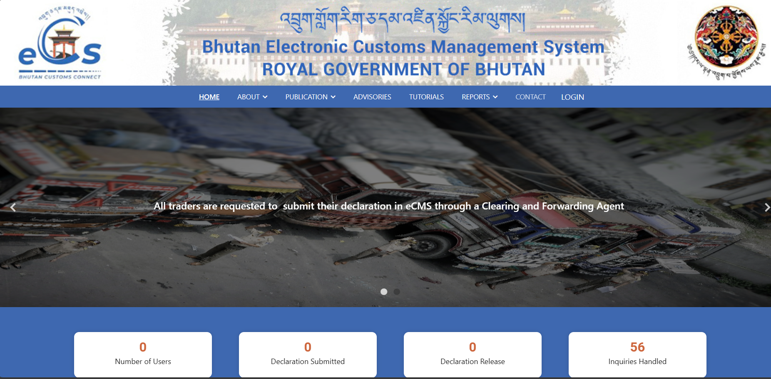

- Click on login menu and provide the required credentials to log in to the system:

Create Air Cargo Manifest

- Select Air Cargo Manifest for the list of menus provided in the dashboard:

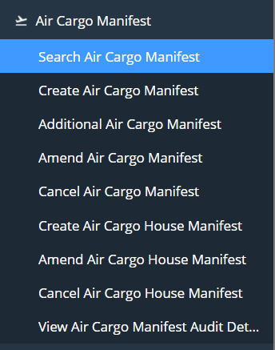

- Under the Air Cargo Manifest menu, Select Create Air Cargo Manifest:

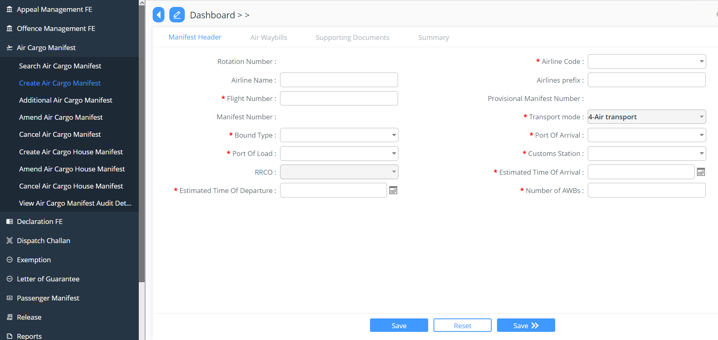

- Key in the following details:

- Manifest Header: here the applicant needs to provide the details of the flight and no of passenger details, filling in all the required:

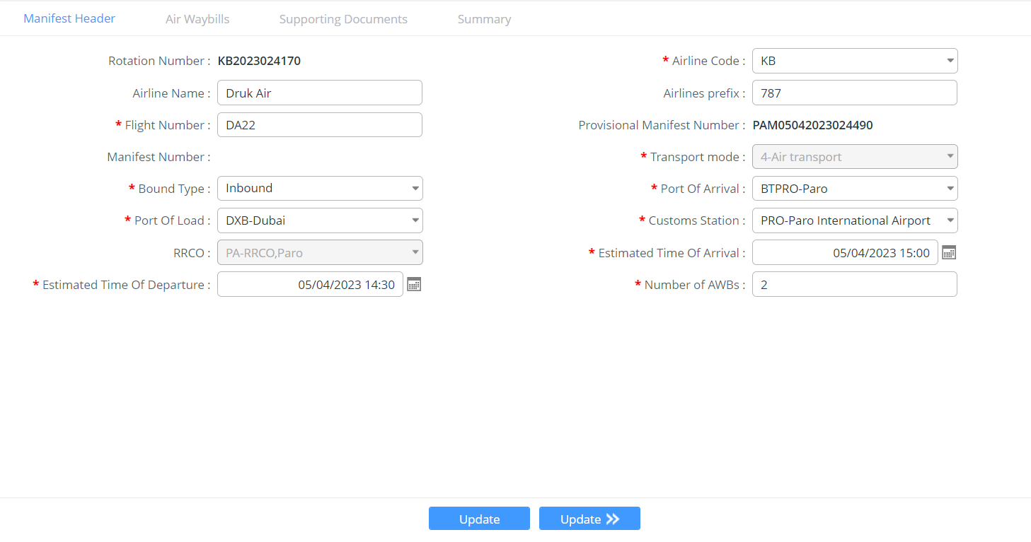
- Air waybills: to add in the airway bills details:

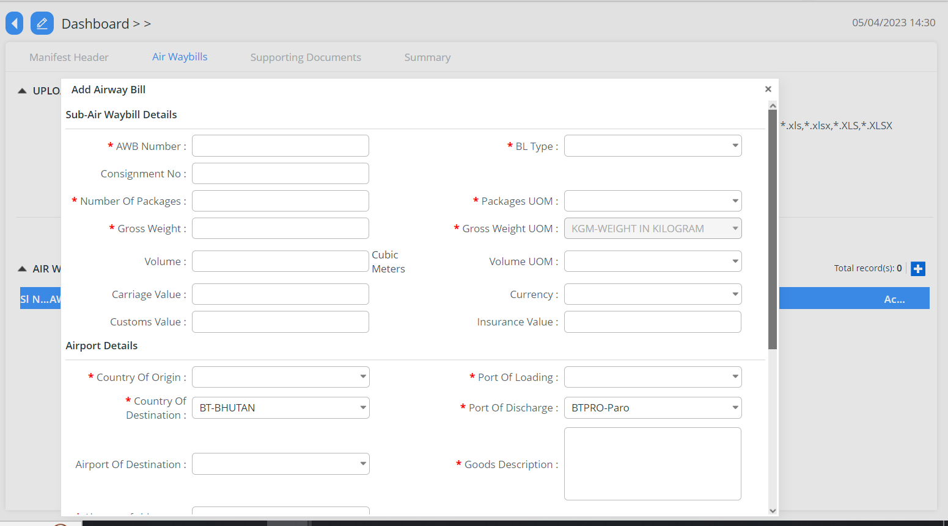

- Supporting Documents: The declarant shall attach any supporting documents (invoice, packing list etc) for approval:

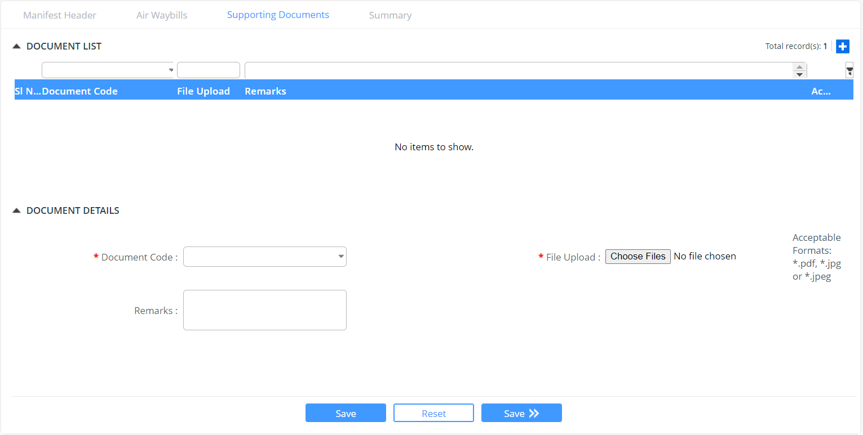

- Summary: The declarant can review his/her air cargo manifest declaration and submit the same for approval:

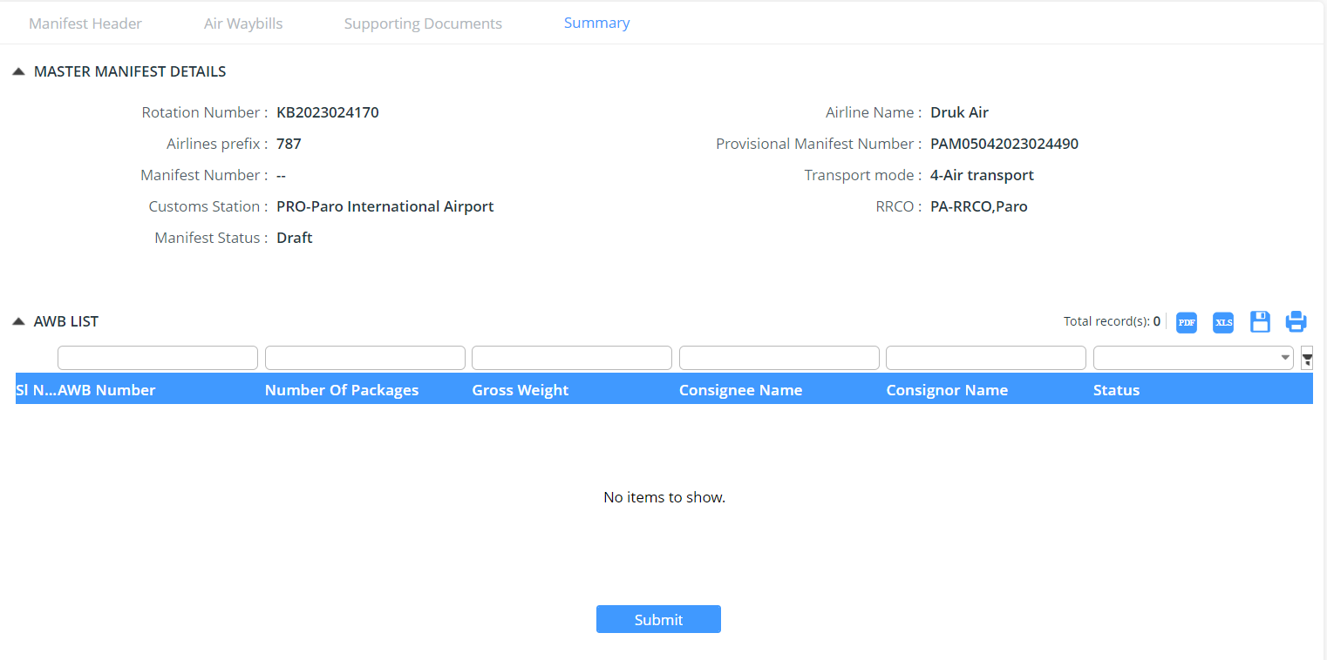

Track Application

- An application Number will be Generated:

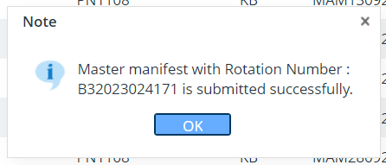

- The users will be able to track their application from Search Air Cargo Manifest:

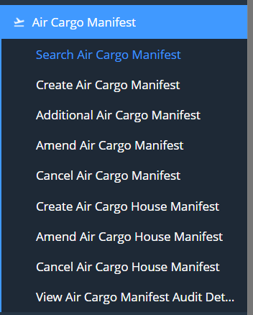

Additional Air Cargo Manifest
This will allow the user to create additional air cargo manifest, if they have missed additional detailed missed in the previous manifest:

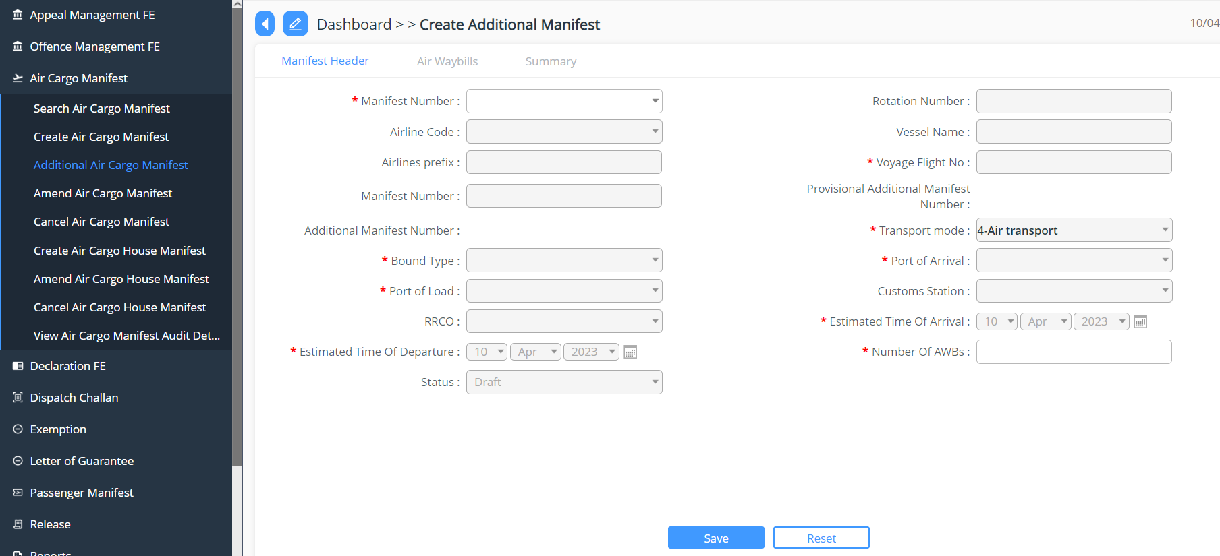

Amend Air Cargo Manifest
The manifest that has been applied for can be amended that can be done by applying the amend request for the submitted manifest.

- Click on the Amend Air Cargo Manifest
- Click on the  button to add in the request
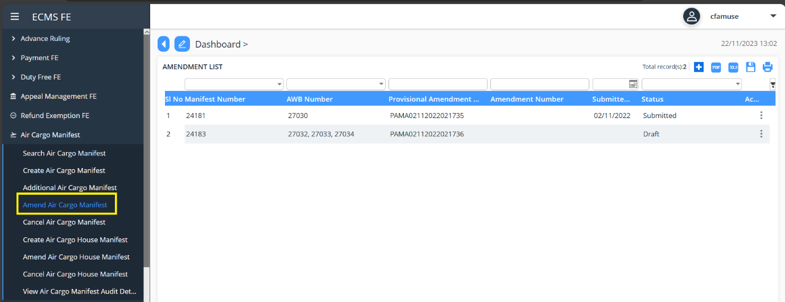

- Fill in the details in the field providing but first need to select the Manifest number that needs to be amended, select the AWB Number then add in the reason for amendment >> Save

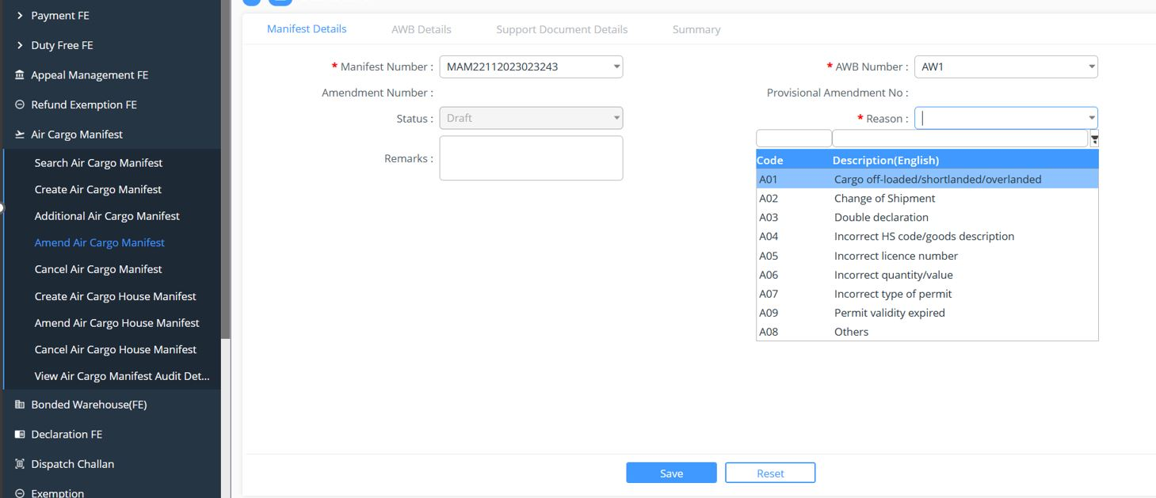

Cancel Air Cargo Manifest
The manifest that has been applied for can be cancelled. Cancellation happens to the manifest which has been submitted.

- Click on the Cancel Air Cargo Manifest
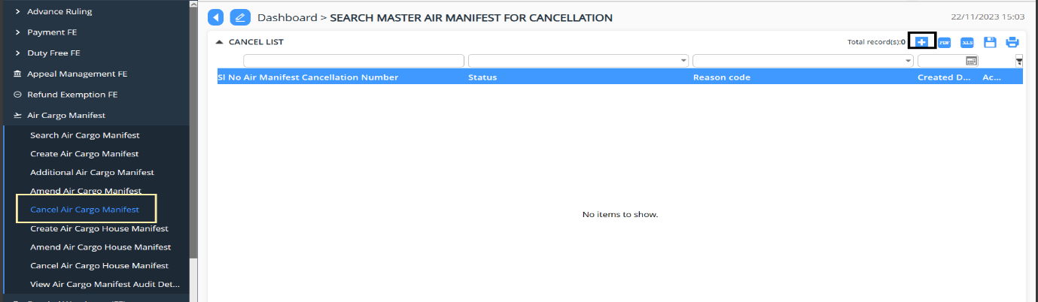

- Click on button to select the manifest which 1 needs to be cancelled.

- Select the manifest number under the tab Manifest Number, then the Manifest Cancellation Type. Here we have two and base on the selected the AWB Number mandatory filed gets highlighted.

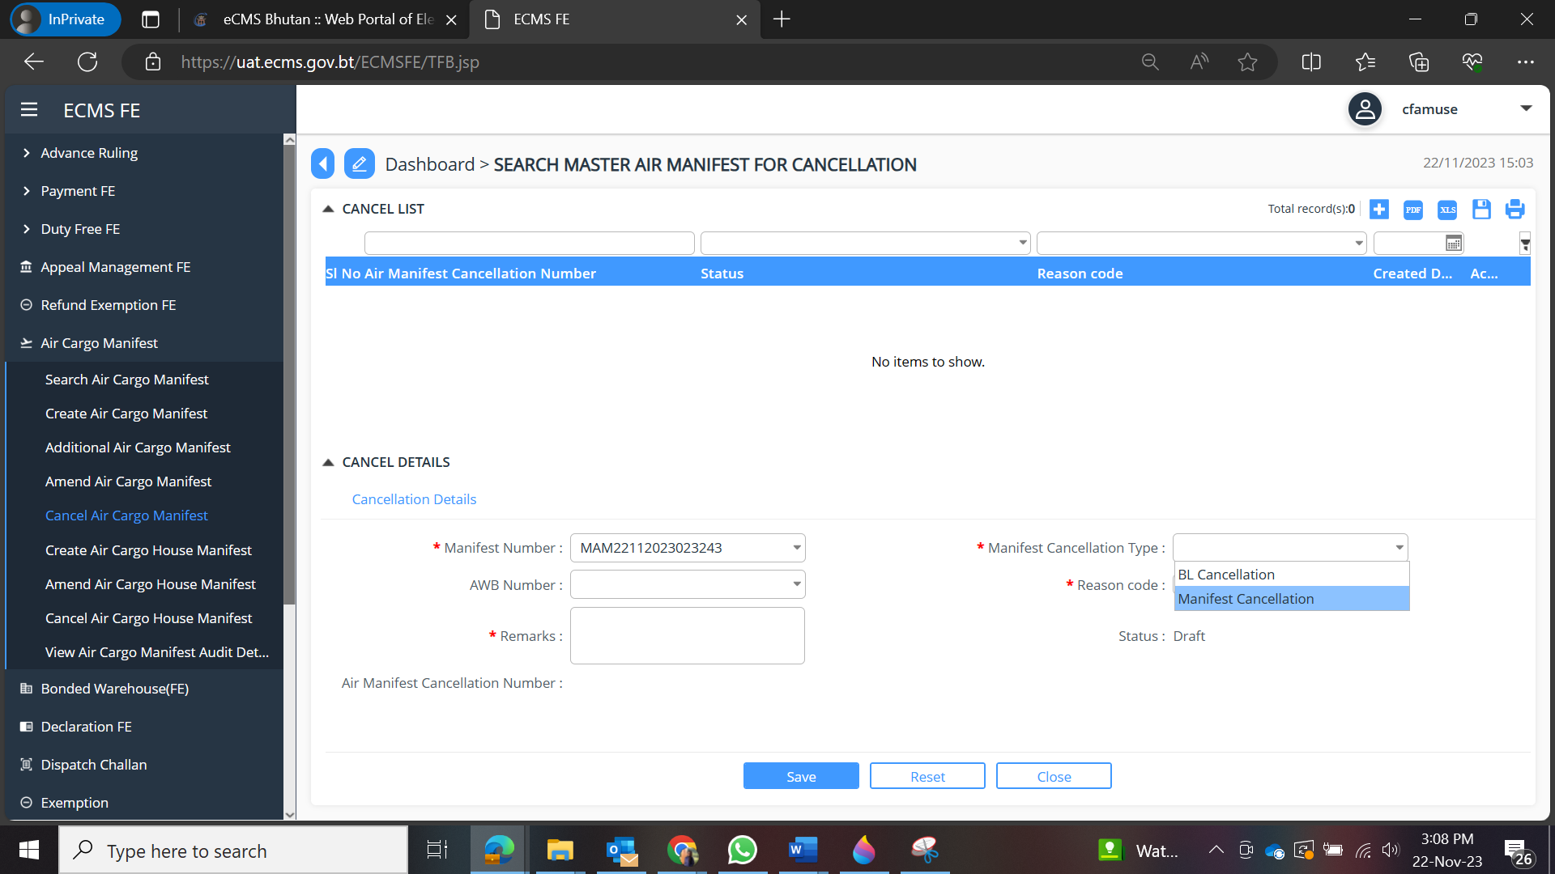

- Fill in the required details and Submit.
- Air Manifest Cancellation number gets generated.

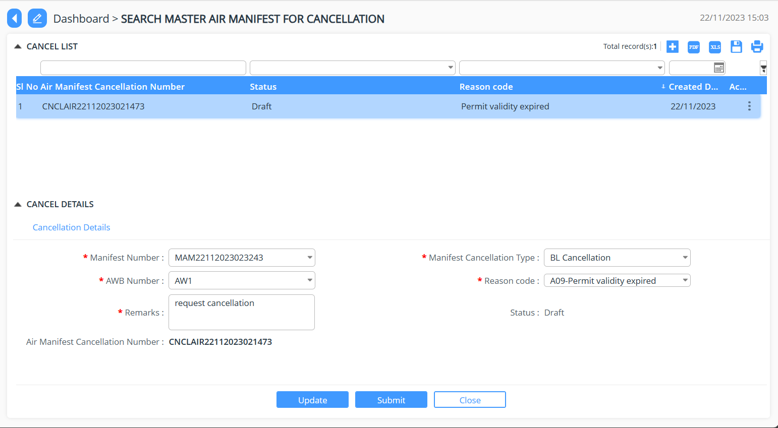
- Double click on the number and then press Submit button.
- Dialogue box with the application number gets generated.

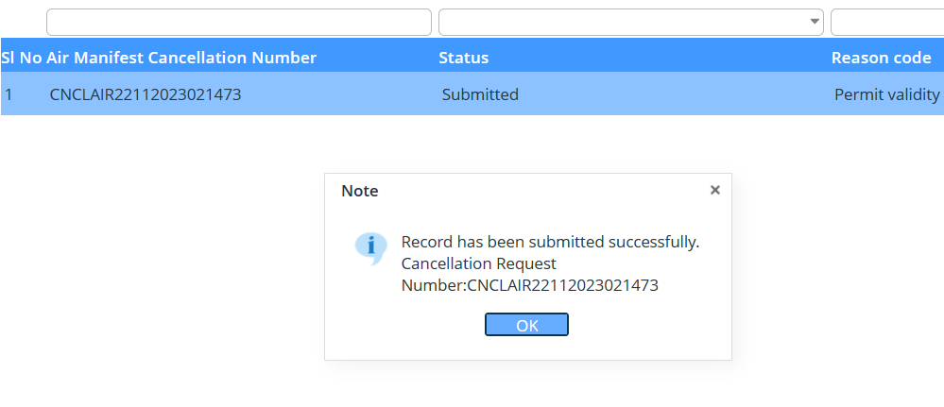
- Once the cancellation is being approved by the concern officer, the status of the application can be viewed from the Search Air Cargo Manifest.

Air Cargo House Manifest
eCMS will enable the user to select a consolidated air waybill that assigned to the user’s party and use it to create a house manifest. House manifests can be created through manual input/upload. eCMS will also enable a customs officer to approve the submission.

Create Air Cargo House Manifest
While creating the Air Cargo Manifest, under the Bill of Lading Tab, if the user has selected the BL Type as Consolidated, then once the Air Cargo Manifest has been approved the declaration will then be available in the Create Air Cargo House Manifest, after that the user can create the Air cargo house manifest and submit the same by providing the details under each header.

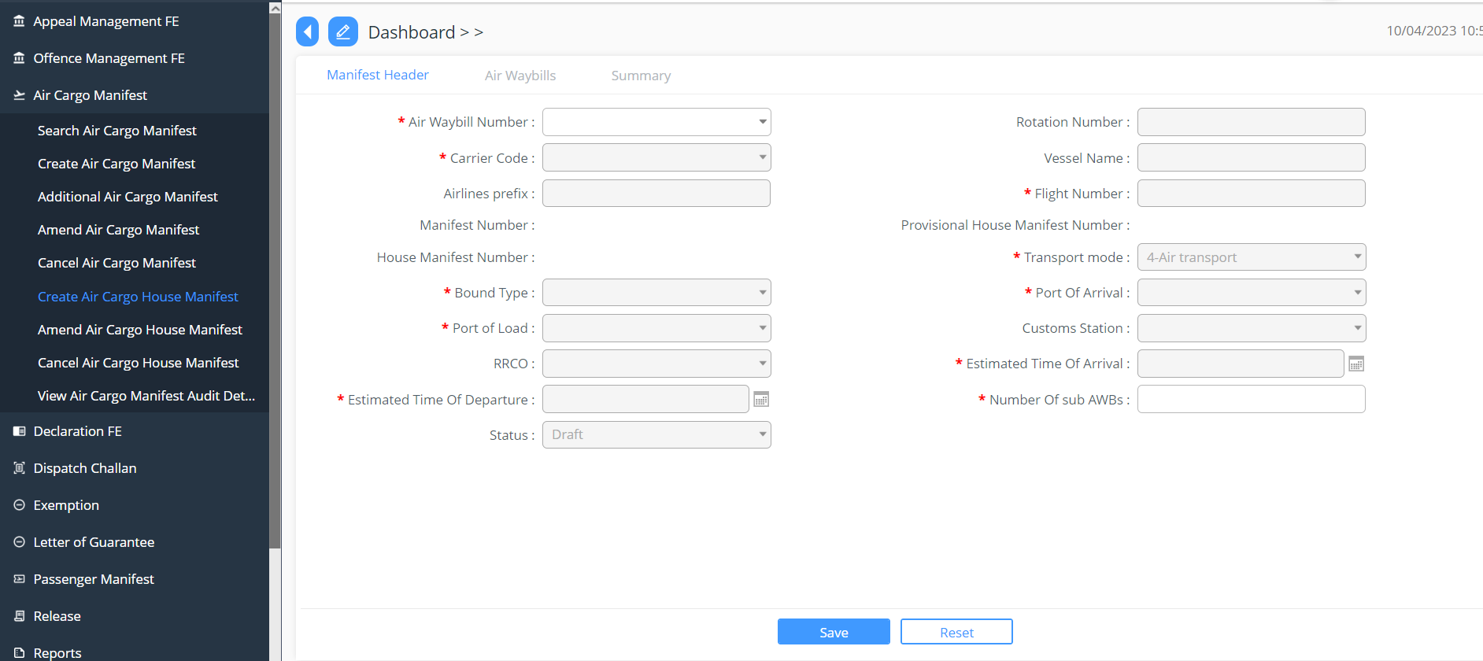

Amend and Cancel Air Cargo House Manifest
The Air Cargo House Manifest once submitted can also be amended and cancelled.

View Air Cargo Manifest Audit Details
Gives the details of the actions considered into the Air Cargo Manifest.
